The Episcopal Church of The Good Shepherd
A Parish of the Episcopal Diocese of Western New York
96 Jewett Parkway • Buffalo, NY 14214

August 5, 2026
The Eve of the Transfiguration
6:30 P.M.
Congregational responses are in bold.

Opening Hymn

God is Spirit, and those who worship must worship in spirit and
in truth. (John 4:24)

Confession of Sin
Let us confess our sins against God and our neighbor.
God of all mercy,
we confess that we have sinned against you,
opposing your will in our lives.
We have denied your goodness in each other,
in ourselves, and in the world you have created.
We repent of the evil that enslaves us,
the evil we have done,
and the evil done on our behalf.
Forgive, restore, and strengthen us
through our Savior Jesus Christ,
that we may abide in your love
and serve only your will. Amen.
Almighty God have mercy on you, forgive you all your sins through our Lord Jesus Christ, strengthen you in all goodness, and by the power of the Holy Spirit keep you in eternal life. Amen.
Officiant O God, be not far from us.
People Come quickly to help us, O God.
Praise to the holy and undivided Trinity, one God:
as it was in the beginning, is now, and will be for ever. Amen.
Except in Lent add Alleluia.

Phos hilaron
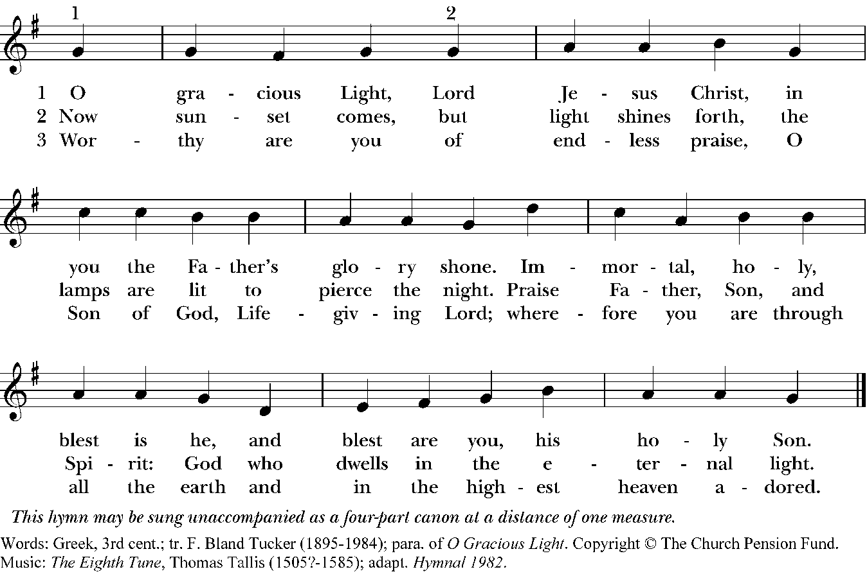

Psalm 99:5-9 (St. Helena Psalter)
said responsively by the half verse
5 We proclaim your greatness, O God,
and fall down before your footstool; *
you are the Holy One.
6 Moses and Aaron among your priests,
and Samuel among those who call upon your Name, *
they called upon you, and you answered them.
7 You spoke to them out of the pillar of cloud; *
they kept your testimonies and the decree that
you gave them.
8 “O Holy God, you answered them indeed; *
you were a God who forgave them,
yet punished them for their evil deeds.”
9 Proclaim the greatness of our God,
and worship on God’s holy hill, *
for our God is the Holy One.

A Reading from Exodus
(34:29-35)
²⁹Moses came down from Mount Sinai. As he came down from the mountain with the two tablets of the covenant in his hand, Moses did not know that the skin of his face shone because he had been talking with God. ³⁰When Aaron and all the Israelites saw Moses, the skin of his face was shining, and they were afraid to come near him. ³¹But Moses called to them; and Aaron and all the leaders of the congregation returned to him, and Moses spoke with them. ³²Afterward all the Israelites came near, and he gave them in commandment all that the LORD had spoken with him on Mount Sinai. ³³When Moses had finished speaking with them, he put a veil on his face; ³⁴but whenever Moses went in before the LORD to speak with him, he would take the veil off, until he came out; and when he came out, and told the Israelites what he had been commanded, ³⁵the Israelites would see the face of Moses, that the skin of his face was shining; and Moses would put the veil on his face again, until he went in to speak with him.

The Word of the Lord. Thanks be to God.

Canticle of the Turning Daigle/Cooley/Donohoo
My soul cries out with a joyful shout that the God of my heart is great,
And my spirit sings of the wondrous things that you bring to the ones who wait.
You fixed your sight on your servant’s plight, and my weakness you did not spurn,
So from east to west shall my name be blessed. Could the world be about to turn?
Refrain:
My heart shall sing of the day you bring.
Let the fires of your justice burn.
Wipe away all tears, for the dawn draws near,
And the world is about to turn.

Though I am small, my God, my all, you work great things in me,
And your mercy will last from the depths of the past to the end of the age to be.
Your very name puts the proud to shame, and those who would for you yearn,
You will show your might, put the strong to flight, for the world is about to turn.
Refrain

From the halls of power to the fortress tower, not a stone will be left on stone.
Let the king beware for your justice tears every tyrant from his throne.
The hungry poor shall weep no more, for the food they can never earn;
There are tables spread, every mouth be fed, for the world is about to turn.
Refrain

Though the nations rage from age to age, we remember who holds us fast:
God’s mercy must deliver us from the conqueror’s crushing grasp.
This saving word that our forebears heard is the promise which holds us bound,
‘Til the spear and rod can be crushed by God, who is turning the world around.
Refrain

The Transfiguration
For that one moment, ‘in and out of time’,
On that one mountain where all moments meet,
The daily veil that covers the sublime
In darkling glass fell dazzled at his feet.
There were no angels full of eyes and wings
Just living glory full of truth and grace.
The Love that dances at the heart of things
Shone out upon us from a human face
And to that light the light in us leaped up,
We felt it quicken somewhere deep within,
A sudden blaze of long-extinguished hope
Trembled and tingled through the tender skin.
Nor can this blackened sky, this darkened scar
Eclipse that glimpse of how things really are.

Taken from Malcolm Guite, Sounding the Seasons (2012).

Nunc dimittis

The Holy Gospel of our Savior Jesus Christ, according to Luke

Glory to you, Lord Christ
²⁸Now about eight days after these sayings Jesus took with him Peter and John and James, and went up on the mountain to pray. ²⁹And while he was praying, the appearance of his face changed, and his clothes became dazzling white. ³⁰Suddenly they saw two men, Moses and Elijah, talking to him. ³¹They appeared in glory and were speaking of his departure, which he was about to accomplish at Jerusalem. ³²Now Peter and his companions were weighed down with sleep; but since they had stayed awake, they saw his glory and the two men who stood with him. ³³Just as they were leaving him, Peter said to Jesus, "Master, it is good for us to be here; let us make three dwellings, one for you, one for Moses, and one for Elijah" — not knowing what he said. ³⁴While he was saying this, a cloud came and overshadowed them; and they were terrified as they entered the cloud. ³⁵Then from the cloud came a voice that said, "This is my Son, my Chosen listen to him!" ³⁶When the voice had spoken, Jesus was found alone. And they kept silent and in those days told no one any of the things they had seen.
The Gospel of the Lord. Praise to you, Lord Christ.

Homily

The Apostles' Creed
I believe in God, the Father almighty,
creator of heaven and earth.
I believe in Jesus Christ, his only son, our Lord.
He was conceived by the power of the Holy Spirit
and born of the Virgin Mary.
He suffered under Pontius Pilate,
was crucified, died, and was buried.
He descended to the dead.
On the third day he rose again.
He ascended into heaven,
and is seated at the right hand of the Father.
He will come again to judge the living and the dead.
I believe in the Holy Spirit,
the holy catholic Church,
the communion of saints,
the forgiveness of sins,
the resurrection of the body,
and the life everlasting. Amen.
The Prayers
The Lord be with you.
And also with you.
Let us pray.

That this evening may be holy, good, and peaceful,
We entreat you, O Lord.
That your holy angels may lead us in paths of peace and goodwill,
We entreat you, O Lord.
That we may be pardoned and forgiven for our sins and offenses,
We entreat you, O Lord.
That there may be peace to your Church and to the whole world,
We entreat you, O Lord.
That we may depart this life in your faith and fear, and not be condemned before the great judgment seat of Christ,
We entreat you, O Lord.
That we may be bound together by your Holy Spirit in the communion of all your saints, entrusting one another and all our life to Christ,
We entreat you, O Lord.
The Collect of the Day
O God, who on the holy mount revealed to chosen
witnesses your well-beloved Son, wonderfully
transfigured, in raiment white and glistening: Mercifully
grant that we, being delivered from the disquietude of
this world, may by faith behold the King in his beauty;
who with you, O Father, and you, O Holy Spirit, lives
and reigns, one God, for ever and ever.Amen.

The Eucharistic Prayer (Prayer 2, Enriching Our Worship)
Celebrant The Lord be with you.
People And also with you.
Celebrant Lift up your hearts.
People We lift them to the Lord.
Celebrant Let us give thanks to the Lord our God.
People It is right to give our thanks and praise.

We praise you and we bless you, holy and gracious God,
source of life abundant.
From before time you made ready the creation.
Your Spirit moved over the deep
and brought all things into being:
sun, moon, and stars;
earth, winds, and waters;
and every living thing.
You made us in your image,
and taught us to walk in your ways.
But we rebelled against you, and wandered far away;
and yet, as a mother cares for her children,
you would not forget us.
Time and again you called us
to live in the fullness of your love.
And so this day we join with Saints and Angels
in the chorus of praise that rings through eternity,
lifting our voices to magnify you as we sing (say):
Holy, Holy, Holy Lord, God of power and might,
heaven and earth are full of your glory.
Hosanna in the highest.
Blessed is he who comes in the name of the Lord.
Hosanna in the highest.
Glory and honor and praise to you, holy and living God.
To deliver us from the power of sin and death
and to reveal the riches of your grace,
you looked with favor upon Mary, your willing servant,
that she might conceive and bear a son,
Jesus the holy child of God.

Living among us, Jesus loved us.
He broke bread with outcasts and sinners,
healed the sick, and proclaimed good news to the poor.
He yearned to draw all the world to himself
yet we were heedless of his call to walk in love.

Then, the time came for him to complete upon the cross
the sacrifice of his life, and to be glorified by you.

On the night before he died for us,
Jesus was at table with his friends.
He took bread, gave thanks to you,
broke it, and gave it to them, and said:
“Take, eat:
This is my Body, which is given for you.
Do this for the remembrance of me.”

As supper was ending, Jesus took the cup of wine.
Again, he gave thanks to you,
gave it to them, and said:
“Drink this, all of you:
This is my Blood of the new Covenant,
which is poured out for you and for all
for the forgiveness of sins.
Whenever you drink it,
do this for the remembrance of me.”
Now gathered at your table, O God of all creation,
and remembering Christ, crucified and risen,
who was and is and is to come,
we offer to you our gifts of bread and wine,
and ourselves, a living sacrifice.

Pour out your Spirit upon these gifts
that they may be the Body and Blood of Christ.
Breathe your Spirit over the whole earth
and make us your new creation,
the Body of Christ given for the world you have made.
In the fullness of time bring us,
with all your saints,
from every tribe and language and people and nation,
to feast at the banquet prepared
from the foundation of the world.

Through Christ and with Christ and in Christ,
in the unity of the Holy Spirit,
to you be honor, glory, and praise,
for ever and ever. AMEN.

And now, as our Savior
Christ has taught us,
we are bold to say,
Our Father, who art in heaven,
hallowed be thy Name,
thy kingdom come,
thy will be done,
on earth as it is in heaven.
Give us this day our daily bread.
And forgive us our trespasses,
as we forgive those
who trespass against us.
And lead us not into temptation,
but deliver us from evil.
For thine is the kingdom,
and the power, and the glory,
for ever and ever. Amen.
The Celebrant breaks the consecrated Bread.
A period of silence is kept.
Alleluia, Christ our Passover is sacrificed for us;
Therefore let us keep the feast, Alleluia
The Gifts of God given for us, the beloved of God: Come and be fed.
Communion Hymn
Prayer after Communion
Let us pray.
God of abundance,
you have fed us
with the bread of life and cup of salvation;
you have united us
with Christ and one another;
and you have made us one
with all your people in heaven and on earth.
Now send us forth
in the power of your Spirit,
that we may proclaim your redeeming love to the world
and continue for ever
in the risen life of Christ our Savior. Amen.

Our worship has ended, our service continues:
Go in peace to love and serve the Lord.
Thanks be to God.

